**Voice-Recorder-for-Voiceprint-Testing**

**Install Docker**

<https://www.docker.com/products/docker-desktop>

Run in linux container mode. No need to "click" windows containers during installation.

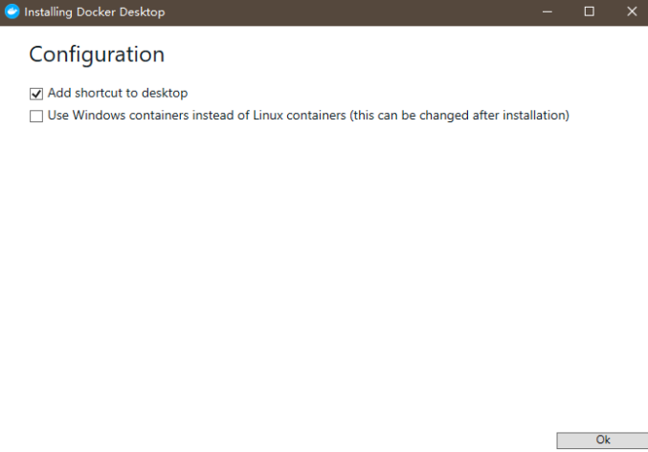

After installation and restart, a warning about Hyper-V and docker containers will pop up. Just click "OK" to restart the computer again.

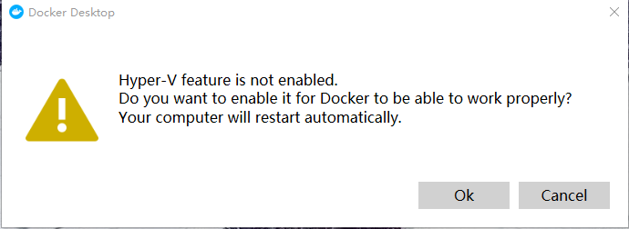

**Docker shared Drives setting**

Edit the "Settings" of docker at the bottom right of the screen: Add the local Drives where this package files are put.

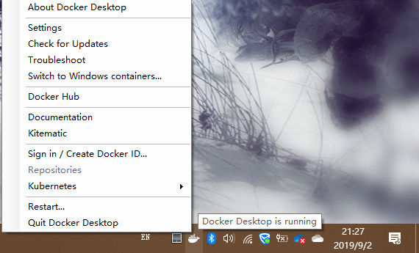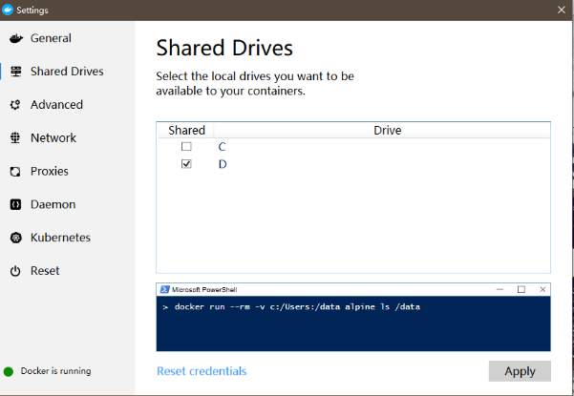

**Run the Voice Recorder Website (Apache Server in Docker)**

Use PowerShell on Windows 10 and cd to the root path of this folder.

Run “docker-compose up”

Then use Chrome to browse [https://localhost:8443](https://localhost:8443/) or [https://0.0.0.0:8443](https://0.0.0.0:8443/).

The code of the webpage is in the "website" folder.

**Voice Recorder Procedure**

* Page Index:

Key in Username and Get Consent on Collecting Data.

Before the recording, please make sure that the participant agrees for the data collection and development.

* Page Fixed Letter 1,2,3,4 & Random Speech 1,2:

For each webpage, press "Start" button to start recording and "Stop" button to stop recording.

After recording, press "Download" button to save .wav files to "Data" folder.

**Voice Recording Summary**

In the "py" folder, there are some python code to extract information from .wav filenames into an excel.

For data security, the method to change username into anonymous ID is also provided.